Time to be proud

Knowing who I am, what I am, what I like, took a while. I grew up always figuring out other people, but never myself. Not knowing that I was, am, gay for 22 years. Questioning myself all the time, trying to figure out what’s wrong with me? Instead finding the wrong answers and learning to better understand others, in the hope that at some point, someone will like me. Why could I not get a girlfriend? My younger brother seemed to have figured it out, why can’t I? Sounds silly now, but these are the questions I kept asking myself through adolescence. It felt like nobody wants me. Am I to ugly? to goofy? to awkward? Being gay was something unknown, something you joke about at primary school not knowing any better.

This left a mark on the rest of my life. Outing myself to my family, to colleagues at work, even to friends, it all had to be difficult, always fearing rejection: living a life of fear.

I cannot simply let bygones be bygones. Even at my 46 years old, this history leaves bitterness everywhere.

I’m writing this in the hope that others may learn from this. Learn to figure out who you are in an environment where it is acceptable, where there is no longer the taboo and the resulting discrimination. But also I’m writing this for myself as I am now finally able to be proud.

Living in a world where we recognize our differences, help others recognize how they are different not to make fun of them, but to recognize each person. Everyone is different. We are not simply either weak or strong. We are different so we can figure out how we can each contribute, share, love, others, in our very own way. From our differences we learn self-respect, we learn to be proud of who we are.

2023 (June) – Global pride month and the Alight’s black on yellow joins the LGBTQ colors on the company page on LinkedIn. I’m happy that they came a long way since I started working there back in 2004. Back then I could not be openly gay at work.

Promoting tolerance for gay people and adding multi-colored PRIDE to Alights black on yellow logo. <https://www.linkedin.com/company/alightsolutions/>

Still today this does not feel OK to me! Something inside still tears me up when I see this.

Here’s my story, present to past and how it all had to be so much more difficult and painful then it could have been. First the present.

Last month (May 2023), I posted an article on LinkedIn after seeing a documentary about how a Jewish holocaust survivor (Gronowski) was able to forgive his Belgian/Flemish prison guard from when he was locked up in the nazi-transport center in Breendonck. During the German occupation of Belgium this railway station was used to transport thousands of Belgian Jews and others deemed not fascist-friendly to the concentration camps of the Third Reigh. Grenowski, who survived the war and the camps puts it like this: “We have to forgive otherwise the hate remains on both sides”. This message truly touched me profoundly.

What is often forgotten is that the nazi-regime also targeted gay people who, just like the Jews, albeit in lesser numbers, were exterminated in the same organized and systematic way. This made me think that all these years I’ve been silent. I was part of the silent majority were if, this was 1941, I would also be the victim of this silence. By not speaking up sooner I am to blame. I am to blame for not making others see the stigma and what it can lead to when populist or even fascist politicians are allowed to seize power and govern in that ruthless and inhumane manner. This only leads to death and destruction. So it is time for me to take the stand. Just like I decided to come out as gay in 2020, I still must take the stand against this injustice today. Whether it is an oversight at a workplace that leads to yearlong discrimination or whether it is an organized genocide, it all starts with enough people not caring, becoming indifferent to the plight of other fellow humans.

Murdered for being gay. 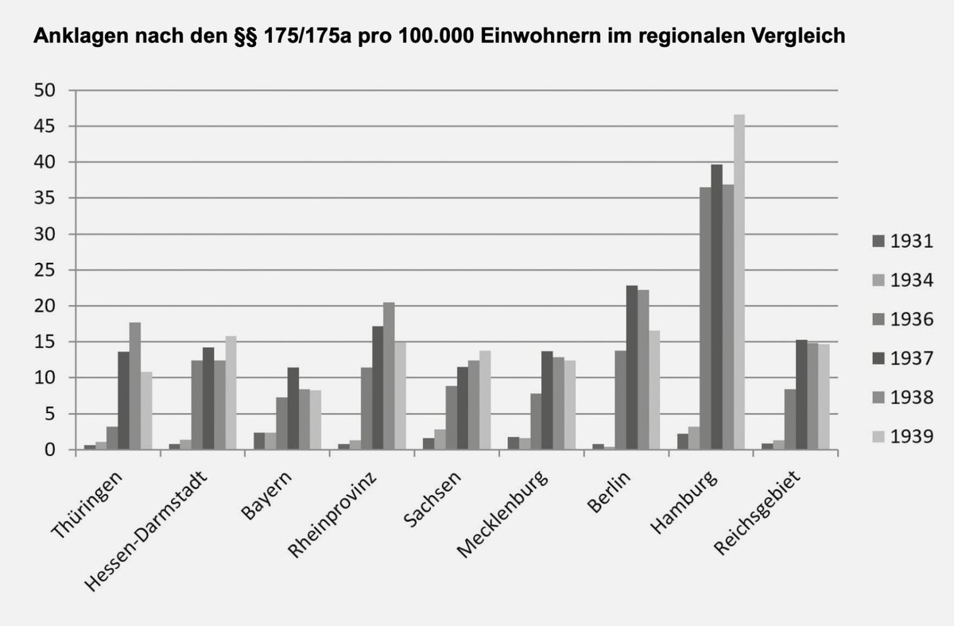Some data about the number of gay persons killed under the Nazi regime in Germany. More on Wikipedia: [Persecution of homosexuals in Nazi Germany - Wikipedia](https://en.wikipedia.org/wiki/Persecution_of_homosexuals_in_Nazi_Germany)

Still struggling with this sour aftertaste of my dismissal at Alight in 2020, I decided to reach out to Alight in the hope they would also recognize things for what they are. In a workplace situation, whether unintended, perhaps not knowing any better, or through deliberate stigmatizing or direct bullying, all these cases lead to discrimination. All I want is they simply “recognize” the discrimination. 16 years long I had to hide myself, who I really am, accept and endure this at work. I was not able to openly gay at work. I had hoped for some understanding that would give me this recognition, that today, I still seek for the pain and suffering I had to go through. I didn’t even yet think of bringing up how all of this contributed to my extended illness. Instead of understanding from Alight, a “Pro-Justitia” mail from Alight’s lawyers ended up in my mailbox at home. It was written with an excessively aggressive tone that was clearly intended to intimidate me. The message of the letter came down to: “Not removing what I posted on social media by next Friday morning would guarantee that I will be sued for slander by Alight”. Here I now stand disappointed whereas I was trying to reconcile with Alight and those at the company that were responsible for the negative culture and climate at the business unit I was in. Bullying was common practice. Internal critical voices, even when necessary, were eventually met with vindictive attitudes by some managers that were deliberately mean and sometimes even to the extend that they meant to set an example for others. Especially criticism on the product strategy and vision, or doctrine as I now prefer to call it, had to be more then outbalanced by almost rehearsed and standard “yeah-sayer-chants”.  
(article <https://www.linkedin.com/posts/stepvda_stephane-van-der-aa-on-twitter-activity-7061072590496227328-GDL-?utm_source=share&utm_medium=member_desktop>)

2020 (March) – Fired for being gay? Fired for coming back to work after an extended illness? Fired for only working part time the first few months back at the job? Fired for not meeting the requirements an skill for my position? Fired for not having received a new job description when appointed to another organization? Fired for not being online on Teams 24/7 during the global pandemic so Alight can always check I am working?

The year of COVID-19 I finally decided, after 16 years working at this company to do my coming out as being gay. This was after recovering from a long medical leave of absence due to mental health issues. For sure many factors played a role in my illness. The moment I no longer found the same joy in my work my entire world started crumbling down. I realized my work for Arinso, then NGA kept me strong and had become my reason for living.

Gently running into colleagues at the office, that I knew well, I told some of them one by one that I am in fact gay: “Hi Fred.” “How are you doing Bart?” “Long time no see.” “I’m better now, but I really want to tell you something”. Each time they reacted in disbelieve. How was this possible that the company told you – me - to stay in the closet back in 2004? I believe, Anita, my then boss and SVP Strategy was the first person I told. I was quiet nervous, not sure if I should feel silly about the whole thing. Still this was important to me as a person. At 43 years old, I have to be comfortable with the person I am and that is only possible if I can be myself. Talking about my private life, my civil union with my late ex-partner Pablo. Never joining those +1 events almost running way when others started leaving to office towards the event venue… each time this culminating awkwardness. But on the every day office floor I had to be that other person, single and even possibly and believably straight.

2019 – NGA prides itself on diversity in social media

Alight had not yet acquired the NorthgateArinso or NGA HR.

<https://www.linkedin.com/posts/cristina-sevilla-alonso-4b20b53_wearengahr-proudtobenga-activity-6551730491345641472-9NMK?utm_source=share&utm_medium=member_desktop>

In 2010, it was almost 2 years that my previous relationship ended and I was ready for a new commitment. This is when I met Wim. We both were in similar place in our lives and in our mind. We wanted something serious, something lasting and the love we felt helped us put aside all those doubts from disappointments from both our previous relationships. Still fully with both feet on the ground, and at Wim’s suggestion we put our love to the test by going on holiday together to Sardinia in the summer 2010. Coming back we committed ourselves and Wim moved in with me.

Zapping back to the work floor, one anecdote. During all this time I was still hiding the fact that I am gay. During my time as part of the euHReka Products team, where I designed 3 modules and worked on quality and pre-sales tasks later it happened that I was called by Wim who got hospitalized. It was on a Friday and we were just about to start our weekly Management Meeting for euHReka. I had to leave to go to Wim. Briefly, maybe without much thinking I told Johan D. another colleague in the management that I had to leave to the hospital as Wim was hospitalized leaving no doubt about the implications: I’m gay, I have a partner, he’s in trouble and I must go to him urgently.

In 2003 I met the first love of my life, Pablo. There’s nothing quiet like the first love, the strongest you ever feel and felt. Madly in love we went for it and although as a gay couple you could not yet get married in Belgium, we signed civil contract which gave us almost all of the rights as a married couple. In 2006 Belgium was, after The Netherlands, the 2nd country in the world that finally approved gay marriage. Happier in life with Pablo, then I ever thought possible before, I still had to do a lot of other figuring out. At the time I was not out at work, but this relationship with Pablo gave me the determination to get it right and take this step…. the next time….. It’s not easy finding this courage, it is a step into another dimension, where you have know clue what reality is or will bring. Though I had the courage, I still had my fears to do this and all the doubts that come with it. But I was enjoying a few happy years with a bit more luck, or so it felt. In September 2004, I received a phone call from a CEO of a Belgian listed country called Arinso. Jos Sluys had heard of my work in the field of document management at DMR Consulting and wanted to hire me right away to work on a great new exciting project as part of one of the first HR BPO Outsourcing deals in the world.

After a few calls and meetings we were all even more excited and I decided to join Arinso. The next day I went to se the HR VP to sign my contract. This is where I wanted to gather all that courage I was talking about before.

Seven years ago, Pablo died after a long struggle with cancer. The picture bellow is from friends and family where we went to scatter his ashes on a beach. He was only 42 years old when he died. Until now, and the publishing of this article, I was never able to tell any colleague of even Pablo’s existence and what he meant to me.

During my first period at Arinso, SCT, there was an incident where the team started a blog. Everyone contributed, including, Pat, manager of SCT. At one point the tone of several posts on our blog became highly suggestive about “sausages” and in my view heavily, to heavily pointed at one team member. Though implicitly it clearly read like, look sausages, he’s gay. I wasn’t okay with this. I couldn’t go to our manager as he was in on the homophobe jokes. So I decided to go to the one person who knew back then that I am gay, our VP HR Samir. He acted immediately and the blog was removed altogether. What shocked me the most is that at the end of it our team manager organized a brief meeting, not to express his support for this action taken by HR, but to express his profound disappointment that this was not brought directly to his attention. He felt I went around his back. This is true, and I did. However, this shows how scared I was about being “discovered” as “gay” that I could not trust my line manager. Many will find this difficult to see, after all you need a good working relationship with your boss

. Being “in the closet” is a very claustrophobic experience that changes your entire way of viewing the world and how you interact with it.

Most people luckily never had to through such an experience, though we need to be ever watchful now that we see how targeted information and advertising is starting to have a “boxing-in” effect on individuals. This leads to an isolation from the rest of the world by having them construct their very individual and view on the world fed sometimes entirely by personalized information from social media. When people now meet in real life, we start to have less and less truly in common, it’s all been taken away by our virtual personalization boxes mainly driven by the “add-based” business model on the internet. The new range of generative AI with ChatGPT and alike will accelerate the personalizing of content even further.

Never forget to be human and keep trusting others to be human with you.

**Weird coincidences**

Why did Boris Vanrillaer pop-up in my childhood? He was also member of the VVWGO-windsurfing-club in Ostend. I was born and raised in that city, he was not and came all the way from Leuven to the coastal town. For a period of 3-4 years I recall crossing him from time to time. Not sure if this has something to do with anything, but I can’t help but wonder whether or not he decided to start to bully me early on. Maybe he had an idea about my sexuality before I did from our encounters over there? Not sure what would have given him idea. Back then he was the type of person who despite all the niceties always gave me an uncomfortable feeling. To me the fact remains that he openly implied ridicule during the “pink-bar-chart-meeting” before I started outing myself at Alight.

Boris Vanrillaer, my former colleague, now unmasked as an abuser who, probably never, did anything else then manipulating other people and getting away with it for far too long. This is a bold claim, I’d like to call it an accusation, but for it is now about self respect and making a statement, that I